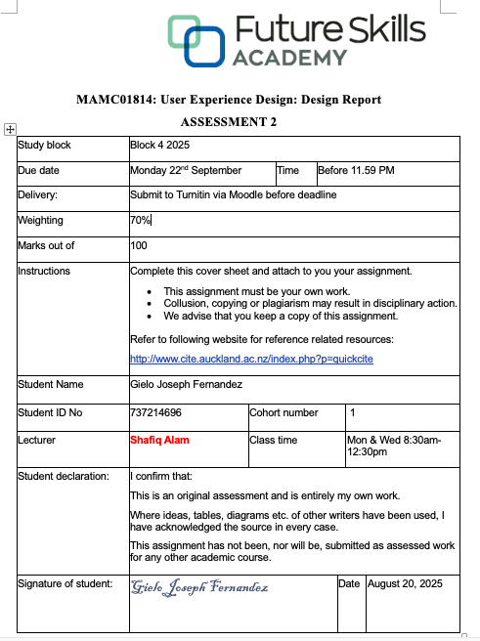

A Critical Analysis of User Experience Design on AA Travel Insurance Quote Page
1. Introduction
“If it doesn‘t feel right, who cares if it works?” This is a known saying from Don Norman, pioneer in user-centered design (Kushendriawan et al., 2021). In today’s age, User Experience plays a huge part in success or failure of organizations. While Don Norman coined the term “user experience” for his group at Apple Computer in 1993. The concept of user experience goes back as early as 1945 (Nielsen, 2017). User Experience (UX), also known as UX, is defined as a person's subjective perceptions and responses that result from the use or anticipated use of a product, system, or service (Kushendriawan et al., 2021).
AA Insurance, a New Zealand company founded in 1994. AA Insurance has been offering insurance to New Zealanders for 30 years (Our Company and Our People - Find out More | AA Insurance, n.d.). AA insurance can leverage user experience to improve its services and increase revenue.
This report will analyse how user experience design can improve the functionality of travel insurance in AA Insurance company. Part two will discuss in detail the user experience elements, usability, accessibility, and aesthetics as they are important in achieving the goals of AA Insurance in the insurance industry. Part three will discuss the best practices of current organizations in how they implement these user experience elements. Part four will discuss Alternate design to further improve the user experience design of AA Insurance. Part 5 will end with summary and conclusion.
2. Analysis of the Current AA Travel Insurance
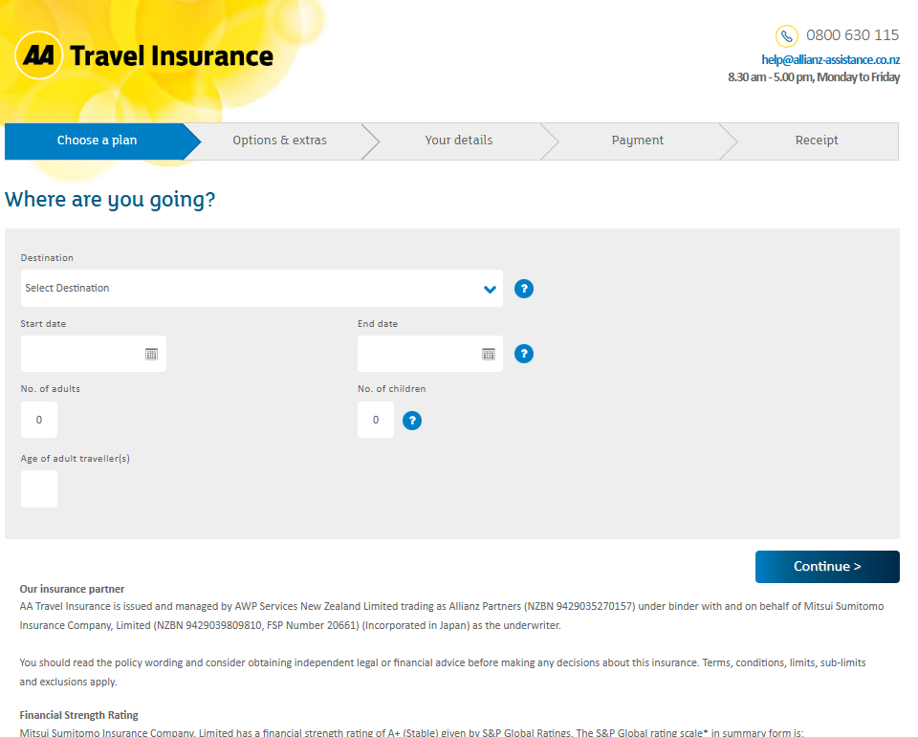
Figure 1 AA Travel Insurance Quote Page
In the figure above, the AA Travel Insurance Quote Page (AA Travel Insurance, n.d.) provides services such as domestic, and overseas travel insurance. It asks for the destination, start date, end date, number of adults, number of children, and the ages of the travellers. In case the user needs help, the page contains the email, contact number and the availability of the travel insurance agent.
The figures below will discuss in detail the components of AA Travel Insurance Quote Page.

Figure 2 AA Travel Insurance Logo
The quote page contains the logo (figure 2) of AA and the label Travel insurance. This is to help the users know that they are accessing the travel insurance and not to be confused with other insurances offered by AA.
Figure 3 Travel Insurance Steps
The quote page contains the phases/steps (figure 3), which guides the users throughout the travel insurance purchase cycle. This helps users know what phases/steps and be guided accordingly.

Figure 4 Insurance agent contact info
The quote page contains the contact number, email address, and the availability of the insurance agent. This is to inform the user if they have any questions or need assistance.
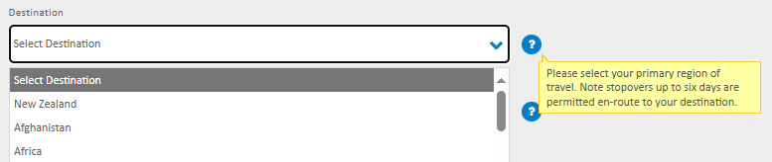
Figure 5 Select Destination
The quote page contains the select destination field, which asks the user to select the destination of their travel. In the scenario that the user is going to multiple countries, there is the tooltip that is displayed when hovered which informs the user about it.
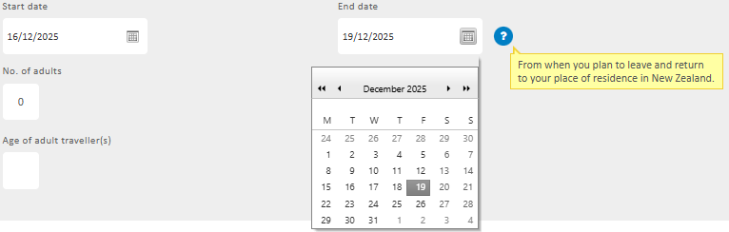
Figure 6 Select Start and End Date
The quote page contains the field where select start and end date, which asks the user to select when the start and end of their travel. It is in calendar format to help to easily identify the dates. There is added tooltip to inform the user more information about the dates.
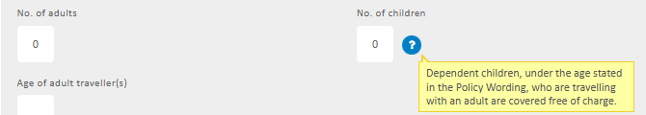
Figure 7 Enter No. of adults and children
The quote page contains the fields to enter the number of adults and children. This is to indicate how many adults and children will be covered in this travel insurance policy. There is added tooltip to inform the user more information about the children.
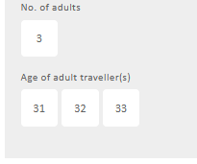
Figure 8 Age of adult traveller(s) Field
The quote page contains the field to enter the ages of the adult travellers that will be covered in this policy. The number of fields depends on the number of adults (ex. 3 adults – 3 fields).

Figure 9 AA Travel Insurance Continue Button
The quote page contains the ‘Continue’ button. After the user enters the destination, start date, end date, number of adults & children, and the age of adults. The continue button proceeds to the next step which is the selection of plan.
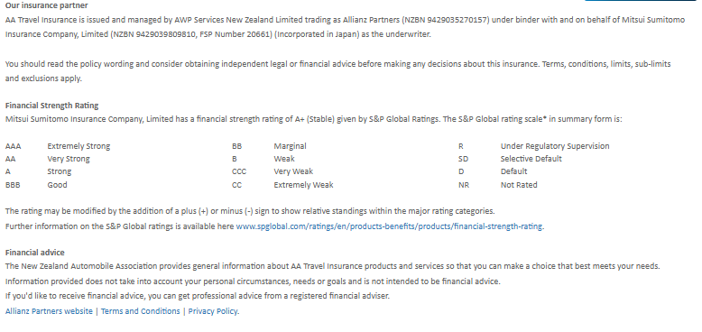
Figure 10 AA Travel Insurance Footer
Finally, the quote page contains the footer, which contains the insurance partner details, financial strength rating, financial advice disclaimer, and other information (partner websites, terms and conditions, privacy policies).
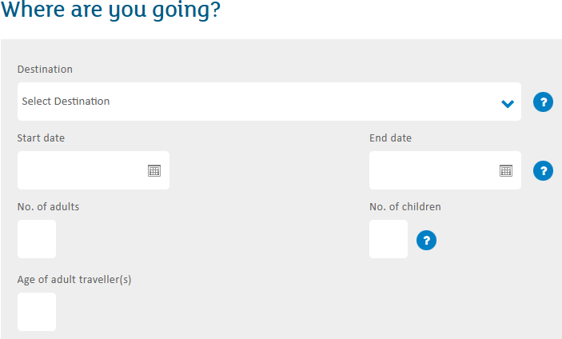
Figure 11 Entering User Info
In terms of usability, the AA Travel Insurance quote page uses simple labels such as ‘Destination’, ‘Start date’, ‘End date’, ‘No. of adults’, ‘No. of children’, and ‘Age of adult travellers’. This is to make sure users are familiar with it even for first time users, as these users spend most of their time on other sites, users expect AA Travel Insurance to function like all the other sites they already know (Nielsen, 2023).
However, there is lacking in the purpose of the traveller, the traveller may have different purposes such as travel, work, and study.
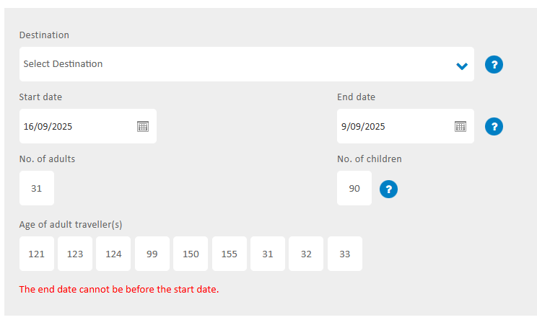
Figure 12 Error Checking
In terms of error checking, while it has the correct error checking message, it can be misleading because the error is located at the bottom of the page, far away from the actual error. This is bad as the error message is best placed near the actual error (Error-Message Guidelines, n.d.).
The absence of chatbot functionality is bad as while the page has the hotline and email address available, it is much more hassle as you need to contact them. When users can easily find the information they need or resolve their issues quickly, they are more likely to be satisfied with their interaction with the chatbot and the business as a whole (Narasimhan, 2025).
3. Evaluation of User Experience Design of AA Insurance Travel Insurance Page
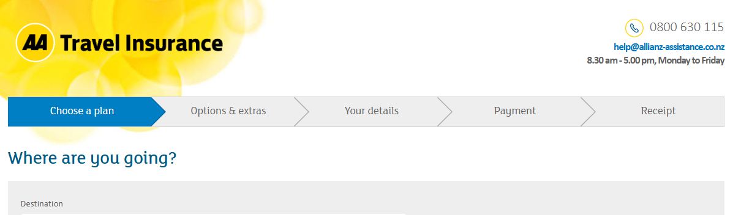
Figure 13 AA Travel Insurance Header
The header (Figure 13) in AA Travel Insurance Quote Page clearly indicates that the user is in the travel insurance page. This is good as it follows the Jakob Nielsen’s ‘Visibility of System Status’, which states that when users know the current system status, they learn the outcome of their prior interactions and determine next steps (Nielsen, 2024). Although, if we compare the headers of other AA insurance products (figure 14 below).

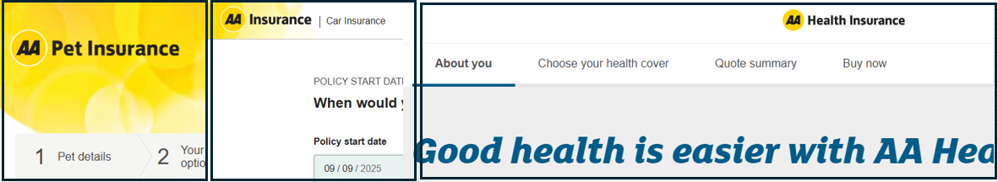
Figure 14 Headers of Pet, Car, and Health Insurance
We see that while the header is similar to pet insurance (AA Pet Insurance | You and Your Pet, n.d.), the header of car insurance (AA | Car Insurance, n.d.) and health insurance (AA | Health Insurance, n.d.) looks a bit different. This is bad as there is no internal consistency between AA insurance products, which is under Jakob Nielsen’s ‘Consistency and Standards’, which states we should maintain consistency within a single product or a family of products (internal consistency) (Nielsen, 2024).
Figure 15 Travel Insurance Steps
The steps as shown in figure 15 in AA Travel Insurance Quote Page is used to guide the user throughout the purchase of travel insurance policy. This is good as it complies with Jakob Nielsen’s ‘Visibility of System Status’, which mentions that to prevent confusion and frustration, it is best to inform them where they are in the process, and in this case the display of progress and loading bars (Nielsen, 2024).
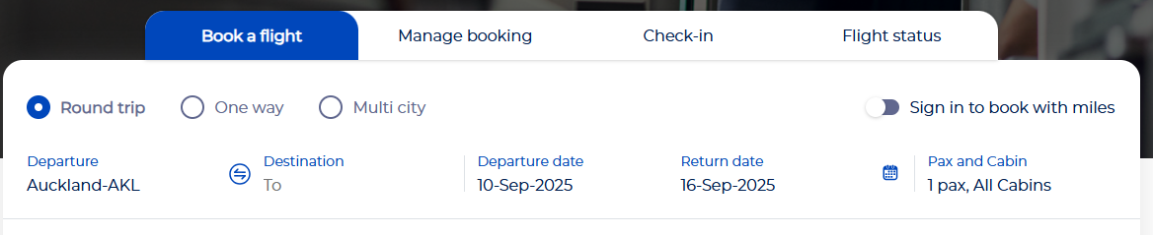
Figure 16 Philippine Airline Booking Page Progress Bar
There are many similar implementation of the progress in other industries, one in which is the figure 16, which shows the progress bar in Philippine Airline Booking Page (Book a Flight, n.d.), mainly used to act as progress bar and guide for the user who wants to book a flight.
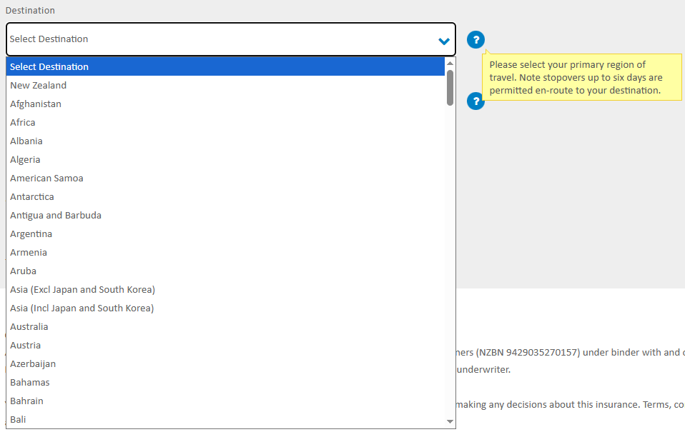
Figure 17 Select Destination Drop Down Menu
The tooltip in figure 17 adds information regarding the destination field. The information is more focused on travellers that are going to multiple destinations. This is good because a tooltip's main purpose is to offer helpful, additional information, aiding users in completing specific tasks (Helin & Eklund, 2023).
Regarding the select destination field in figure 17, AA insurance currently uses a drop-down menu. This is bad as there is quite a really long list of all the countries. If the destination is in the most bottom, you have to scroll all the way down. This violates Fitt’s law where the the farther the distance to the target (ex. destination), the longer it will take for the pointer to move to it (Budiu, 2022). Southern Cross Travel Insurance (Southern Cross Travel Insurance - Compare, Quote, Buy Online | SCTI NZ, n.d.) has a different approach. The figure 18 below shows the Southern Cross Travel Insurance.
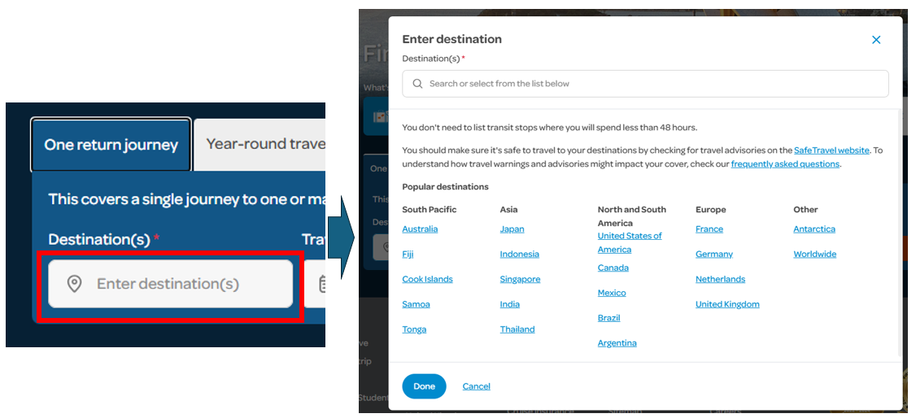
Figure 18 Southern Cross Travel Insurance - Destination Field
In figure 18, after clicking the destination field, a pop-up window appears where the user can either select from the popular destinations or type in the destination in the text field. This is better because it is quicker to select the popular destinations or type in the destination than selecting from a very long list of destinations. There are different approaches designing destination fields in other industries, such as aviation. Figure 19 below shows the destination field in Air New Zealand (Air New Zealand – Book Flights & Earn AirpointsTM, n.d.).
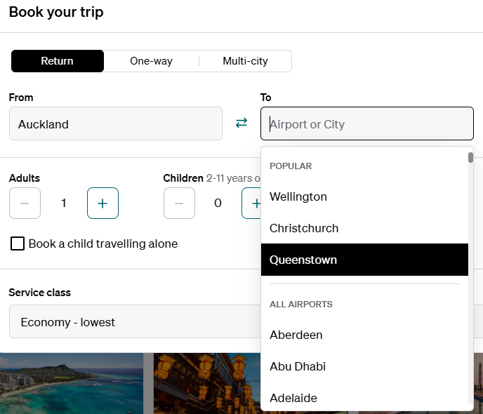
Figure 19 Air New Zealand Destination Field
The Air New Zealand’s (Air New Zealand – Book Flights & Earn AirpointsTM, n.d.) destination field in figure 19 uses a search bar with the popular destinations as the top choices. As the user, the quickest way to fill up the field is to either select from the popular choices or type in the first few characters and select the destination. This is good as this is quicker than the way AA insurance implemented it.
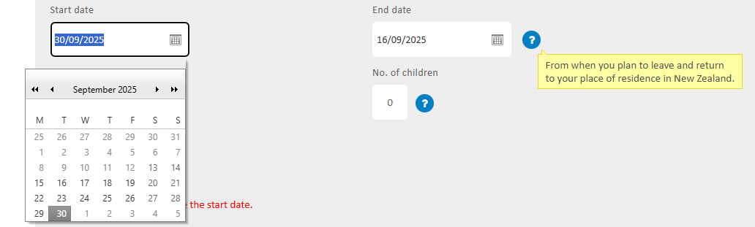
Figure 20 AA Travel Insurance - Start & End date field
In figure 20, AA Travel Insurance uses date picker to easily select date. This is okay as it is better than the text field. On mobile devices, where screen space is limited and touch interaction is primary, a date-picker can be more intuitive and accurate than a text field, which may require zooming functions for clear input. However, there are ways to improve it. If we compare it at Allianz Travel Insurance (Allianz Travel Insurance, n.d.), which is shown in figure 21 below.
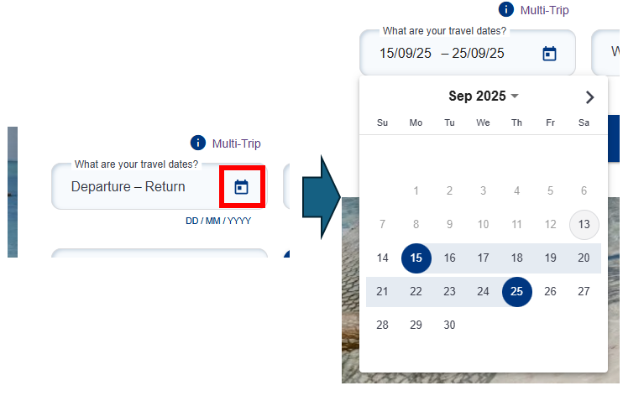
Figure 21 Allianz Travel Insurance Date field
The date picker used by Allianz (Allianz Travel Insurance, n.d.) is much more compact and effective than AA insurance, the user can select the start and end date in the same date picker. It also requires less clicks or actions than AA insurance. This is the goal as designing user interfaces (UIs) to require fewer clicks or actions is a fundamental goal aimed at enhancing user experience, particularly through improving efficiency, reducing cognitive load, and minimizing user errors (Hui & See, 2015). Air New Zealand (Air New Zealand – Book Flights & Earn AirpointsTM, n.d.) implements a similar approach, as shown in the figure 22 below.
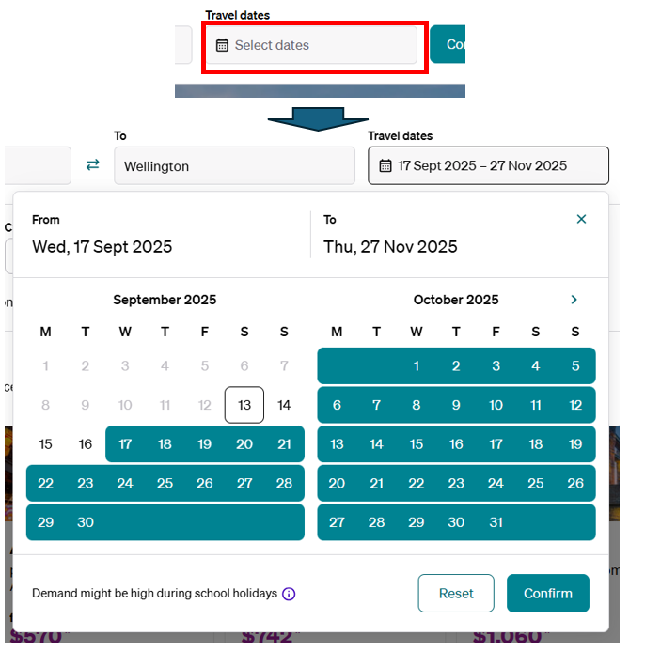
Figure 22 Air New Zealand Select Date Field
The date picker in figure 22 is uses 2 date window to view both the start and end date. The use of animation of filled out colour as visual cues to identify the date range is good for visual appeal. Visuals can compact information, transforming complex data into understandable insights quickly. Aesthetically pleasing and visually engaging interfaces contribute to user satisfaction and can even enhance perceived usability, a concept known as "apparent usability" (Blair-Early & Zender, 2008).
4. Design of the recommended AA Insurance Travel Insurance Page
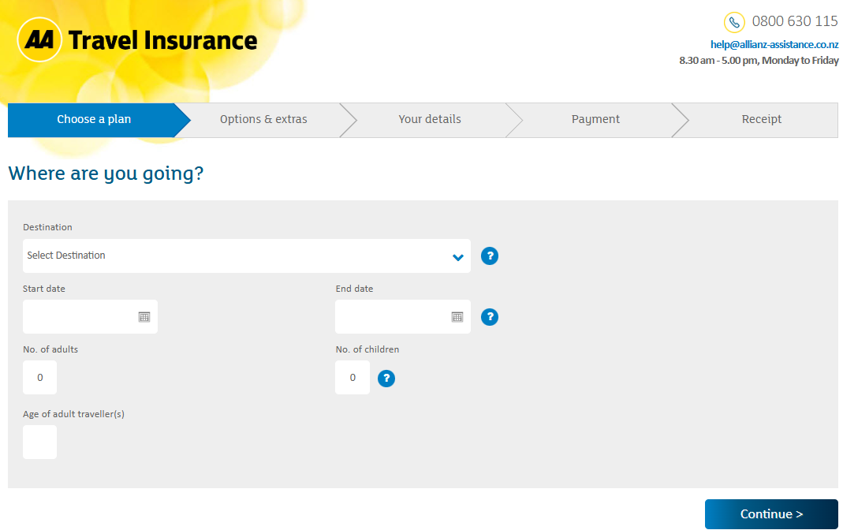
Figure 23 Current AA Travel Insurance Quote Page
The figure 23 above is the current design of AA Travel Insurance Page, and the figure 24 below is the recommended alternative design for AA Travel Insurance Quote Page.
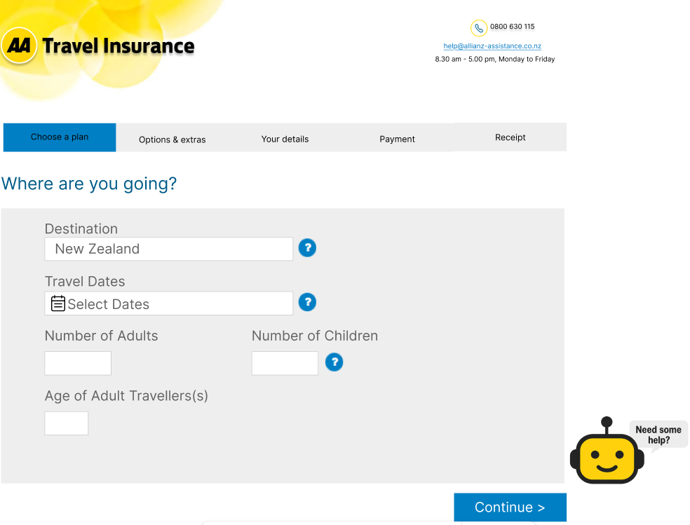
Figure 24 Recommended Design
For mobile browsers, the recommended design is shown in figure 25 below.
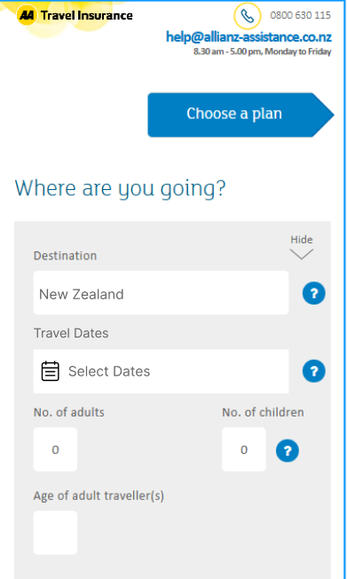
Figure 25 Recommended design (Mobile browser version)
Based on the evaluation done on AA Travel Insurance page, some alternative designs are recommended to improve user experience. Each revision in the design will be discussed in detail below with added screenshots.
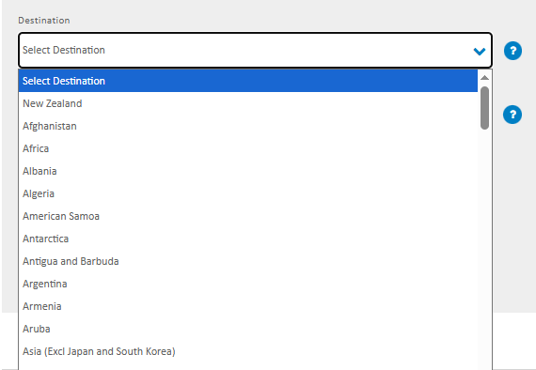
Figure 26 AA Travel Insurance Destination Field
Currently, AA travel insurance uses a drop-down menu in the destination as shown in figure 26 above. A better alternative is to add a search field, and the drop-down menu contains the popular destinations and the list of countries. The figure 27 below shows how it could be implemented.
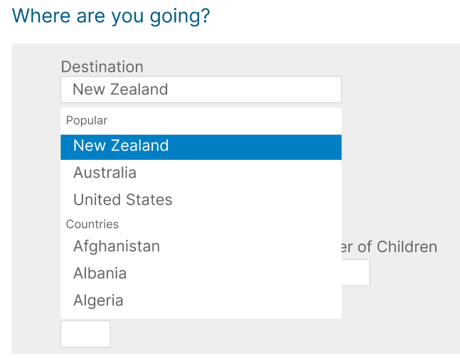
Figure 27 Alternate Destination Field
With the alternate design, the user still has the option to scroll throughout the drop-down list to find the destination, but the user has the option to type it in as it is the faster option.
Regarding the search function, as the user types in each letter, as shown in figure 28 below.
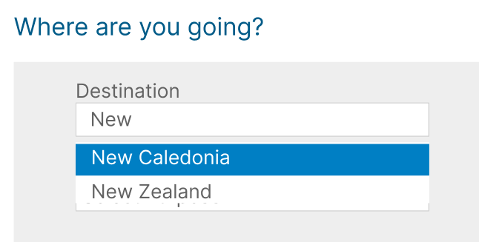
Figure 28 Destination Field Search function
Each letter typed simultaneously searches for the countries that match the search. This enables the customer to find the destination quickly.
Currently, AA Travel Insurance uses 2 separate date field in their select start and end date process, as shown in figure 29 below.
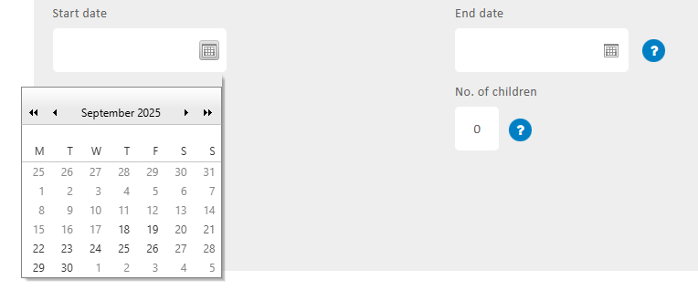
Figure 29 Current AA Travel Insurance date fields
Customising the dates can take more time than usual because there are 2 different date fields for start and end dates. Although there is an error shown, selecting an end date more previous than the start date is allowed, as shown in figure 30 below.
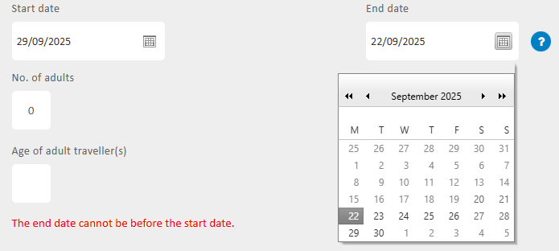
Figure 30 Start and End Date Error Check
A better alternative is to merge both start and end date in one field, as shown in figure 31 below.
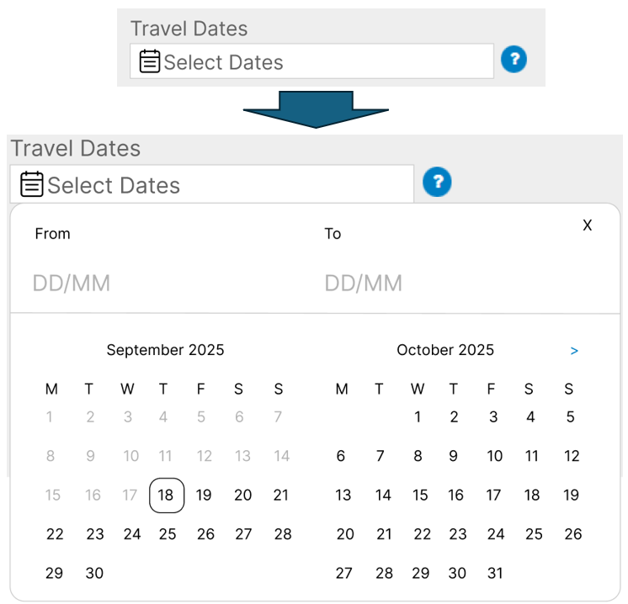
Figure 31 Alternative Start and End Date Field
The user can easily click the start date and the end date since it which can make the interaction quicker with less steps/clicks. It also shows the dates filled to show the user the range of days that they will be covered by the travel insurance, as shown in figure 32 below.
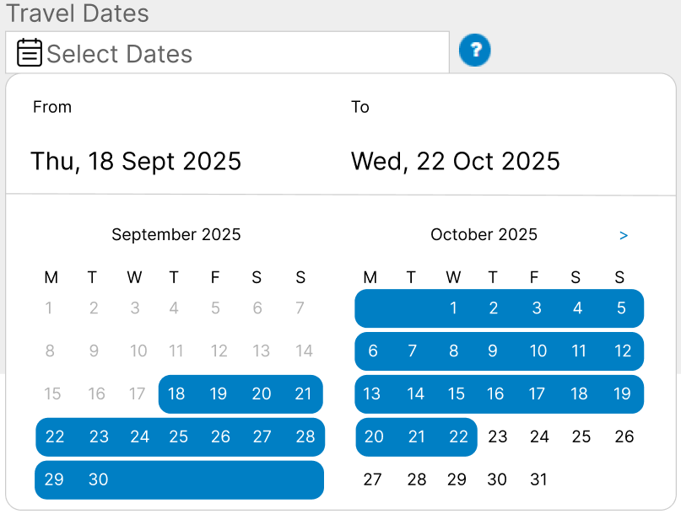
Figure 32 Alternative Start and End Date Field -Filled Out
With this alternate design, the user can easily customize the start and end date, thereby improving the usability of the select date field. For the error checking, the most previous date selected is always considered as the start date and the most future date is always set as the end date.
Currently, AA travel insurance does not have any AI support. AA travel insurance only has hotline, and email address, as shown in figure 33 below.

Figure 33 AA Travel Insurance hotline and email
This is not enough, as customers cannot access the hotline outside working hours and it could have issues with time zone for foreigners. The alternative design has added AI chat support and FAQs link as shown in figure 34 below.
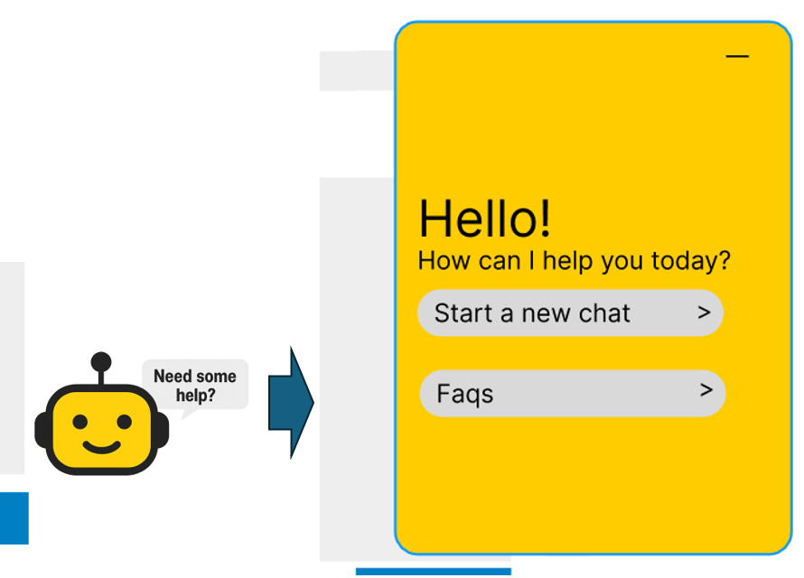
Figure 34 AI Chat widget feature
With the alternative design in figure 34 above, there is the added AI chat widget with the AI chat support. This enables customers to communicate outside AA insurance working hours, which are usually foreigners from other countries. This also enables customers to communicate using foreign language.
When the AI chat widget is clicked, the customer can either start a new chat with AI or view FAQs or commonly asked questions.
With the improvements in the alternative design, providing efficient steps in customer transaction would in turn reduce cost for the AA insurance. Clear, well-designed interfaces reduce user errors, which in turn lowers the volume of customer service requests (Cordeiro & Weevers, 2016)
In addition to reducing cost for AA insurance, an efficient and intuitive design can have a direct and dramatic impact on a company's revenue and profits. A smooth, simple, and clear process is crucial for reducing high abandonment rates (Komandla, 2018).
For desktop or browser applications, efficiency and speed are paramount, as lengthy or complex processes lead to high abandonment rates (Komandla, 2018). A user's perception of a product's quality is directly shaped by its performance, including start-up time, page-loading behaviour, smoothness of transitions, and waiting times (Cordeiro & Weevers, 2016).
Inclusivity and accessibility ensure the design works for everyone. For insurance companies, establishing and maintaining customer trust is a core business objective (Khast, 2017). An accessible and inclusive UI is a direct reflection of a company's commitment to its customers, which in turn fosters loyalty (R. Vergallo & L. Mainetti, 2022).
One of the emerging UX trends nowadays is the use of AI. The user can use voice mode to ask AI to do something for the user. What makes voice mode great is that you can just have a natural conversation with the app while in the car or on a walk and get quite far in understanding what these models can do (Mollick, 2025). In the context of AA insurance, using voice mode to book travel insurance could shift what user experience is and be more focused on being providing user experience through AI.

5. Summary and Conclusion
For AA travel insurance, focusing on the user experience element ‘usability’ is crucial in enhancing customer satisfaction and seamless transaction. Usability can be implemented in AA travel insurance by removing redundant clicks and adding chat/AI support. By focusing on usability, AA travel insurance can lower costs by reducing unnecessary steps and unnecessary errors, and by reducing unnecessary steps and adding a chat/AI support function, it can dramatically reduce high abandonment rates for AA travel insurance.
In conclusion, focusing on usability can help AA travel insurance be a top user preferred travel insurance, in local and international.

6. References
AA | Car Insurance. (n.d.). Retrieved September 10, 2025, from https://go.aainsurance.co.nz/motor/quote.html#policystartdate
AA | Health Insurance. (n.d.). Retrieved September 10, 2025, from https://health.aa.co.nz/about-you
AA Pet Insurance | You and your pet. (n.d.). Retrieved September 10, 2025, from https://sales.aapetinsurance.co.nz/
AA Travel Insurance. (n.d.). Retrieved September 8, 2025, from https://travelinsurance.aa.co.nz/processing/ChooseAPlan.aspx
Air New Zealand – Book Flights & Earn AirpointsTM. (n.d.). Retrieved September 13, 2025, from https://www.airnewzealand.co.nz/
Allianz Travel Insurance. (n.d.). Retrieved September 13, 2025, from https://buy.allianztravel.co.nz/get-travel-insurance
Blair-Early, A., & Zender, M. (2008). User Interface Design Principles for Interaction Design. Design Issues, 24(3), 85–107.
Book a flight. (n.d.). Phillipine Airlines. Retrieved September 10, 2025, from https://www.philippineairlines.com/nz/en/home.html
Budiu, R. (2022, July 31). Fitts’s Law and Its Applications in UX. Nielsen Norman Group. https://www.nngroup.com/articles/fitts-law/
Cordeiro, T., & Weevers, I. (2016). Design is No Longer an Option – User Experience (UX) in FinTech. In The FinTech Book: The Financial Technology Handbook for Investors, Entrepreneurs and Visionaries (pp. 34–37). Wiley.
Error-Message Guidelines. (n.d.). Nielsen Norman Group. Retrieved September 9, 2025, from https://www.nngroup.com/articles/error-message-guidelines/
Helin, S., & Eklund, A. (2023). Evaluating the use of Brush and Tooltip for Time Series visualizations: A comparative study.
Hui, S. L. T., & See, S. L. (2015). Enhancing user experience through customisation of UI design. Procedia Manufacturing, 3, 1932–1937.
Khast, P. (2017). UX/UI Design Process for a Peer to Peer Financial Platform.
Komandla, V. (2018). Enhancing User Experience in Fintech: Best Practices for Streamlined Online Account Opening. International Journal of Multidisciplinary and Current Educational Research (IJMCER), 2(4), 01–08.
Kushendriawan, M. A., Santoso, H. B., Putra, P. O. H., & Schrepp, M. (2021). Evaluating user experience of a mobile health application Halodoc using user experience questionnaire and usability testing. Jurnal Sistem Informasi (Journal of Information System), 17(1), 58–71.
Mollick, E. (2025, June 24). Using AI Right Now: A Quick Guide. https://www.oneusefulthing.org/p/using-ai-right-now-a-quick-guide
Narasimhan, L. (2025, January 8). Chatbot UX: Boosting User Engagement and Satisfaction for Your Business. https://www.thealien.design/insights/chatbot-ux, https://www.thealien.design/insights/chatbot-ux
Nielsen, J. (2017, December 24). A 100-Year View of User Experience (by Jakob Nielsen). Nielsen Norman Group. https://www.nngroup.com/articles/100-years-ux/
Nielsen, J. (2023, September 8). Jakob’s Law of the Internet User Experience. UX Tigers. https://www.uxtigers.com/post/jakobs-law
Nielsen, J. (2024, January 30). 10 Usability Heuristics for User Interface Design. Nielsen Norman Group. https://www.nngroup.com/articles/ten-usability-heuristics/
Our company and our people—Find out more | AA Insurance. (n.d.). Retrieved August 21, 2025, from https://www.aainsurance.co.nz/about-us/about-our-company
R. Vergallo & L. Mainetti. (2022). The Role of Technology in Improving the Customer Experience in the Banking Sector: A Systematic Mapping Study. IEEE Access, 10, 118024–118042. https://doi.org/10.1109/ACCESS.2022.3218010
Southern Cross Travel Insurance—Compare, Quote, Buy Online | SCTI NZ. (n.d.). Retrieved September 13, 2025, from https://insure.scti.co.nz/

